Chapter 2, Problem 59.

Three light bulbs are connected in series to a 120-V source as shown in Fig. 2.123. Find the current I through the bulbs. Each bulb is rated at 120 volts. How much power is each bulb absorbing? Do they generate much light?
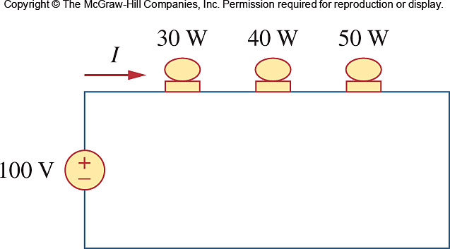

120 V

Figure 2.123
For Prob. 2.59.

